**LONGINES PRIMALUNA**

**A new chapter in feminine horological excellence**

**Longines unveils the redesigned PrimaLuna collection, a complete reimagining that embodies the brand’s philosophy that true elegance evolves while remaining fundamentally timeless. Inspired by the spirit of its first iteration, every element has been thoughtfully designed, from refined case proportions and brand new date display in the moonphase complication to the mastery of gem-setting techniques.** **This artisanal expertise reaches its peak in the extraordinary model, featuring a blue mother-of-pearl dial, encircled by a bezel adorned with 48 carefully selected sapphires that together create a celestial celebration of Swiss horological artistry. This declaration of contemporary feminine sophistication finds its embodiment in Longines Ambassador of Elegance Jennifer Lawrence, whose natural grace and authentic elegance capture the intimate moments where time becomes truly personal.**

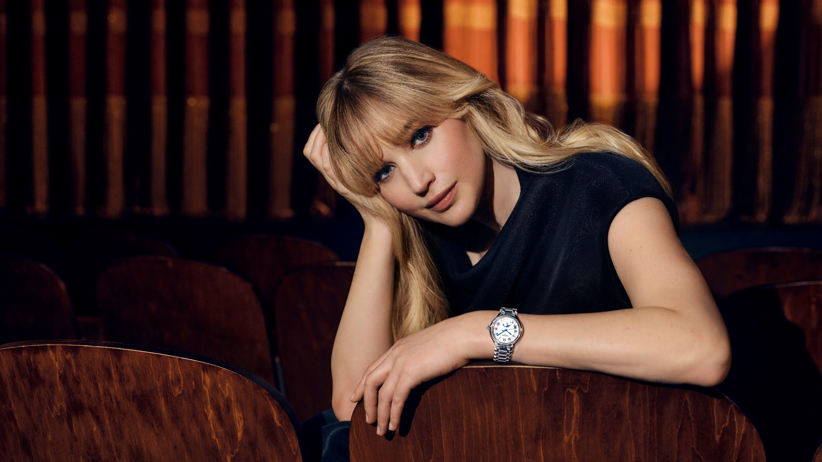

For more than a century, Longines has cultivated an intuitive expression of feminine elegance, creating timepieces that celebrate the sophistication and flair of women everywhere. This expertise in women’s watchmaking – from the gem-set creations of the early 1900s to the complications that grace many of the brand’s timepieces – has established the Swiss watchmaker as an authority in feminine horology. With these new watches, the PrimaLuna collection represents Longines’ commitment to the woman who values elegance in design as well as the precision of Swiss mechanical excellence. With a blend of classic Roman numerals, lustrous dials, and meticulously executed details, each timepiece speaks to those who understand that genuine luxury arises from the confidence of impeccable craftsmanship.

**PrimaLuna 2025: a completely redesigned collection**

The visual transformation of the PrimaLuna begins with its reimagined 34-mm case, where subtle domed surfaces create an interplay of light and shadow that enhances the timepiece’s feminine grace. The crown itself becomes a poetic statement – its bubble-like form evokes the full moon while engravings of lunar crescents encircle its surface, creating a tactile connection to the celestial complication within. Available in stainless steel, elegant bi-material combinations, or adorned with diamonds and sapphires, each case configuration maintains the collection’s refined proportions while offering distinct expressions of luxury.

**Precision in motion**

For the first time in PrimaLuna history, the automatic moonphase complication is joined by a practical date display, powered by Longines' exclusive L899.5 automatic calibre with silicon balance spring technology. This technical excellence extends to exceptional performance, with the movement delivering an impressive 72-hour power reserve that ensures consistent timekeeping throughout extended periods away from the wrist. Water-resistant up to 3 bar (30 metres), each PrimaLuna timepiece offers the reliability of Swiss horological craftsmanship in the delicate proportions that define its feminine elegance. The silicon balance spring technology enhances precision and provides superior resistance to magnetic fields and temperature variations, ensuring lasting accuracy.

**Technical sophistication meets lunar poetry**

The PrimaLuna collection reveals its versatility through three distinct dial expressions. The classic sunray silver dial with blue or black painted Roman numerals embodies timeless sophistication, its lustrous surface catching the light with every movement. For those who appreciate contemporary luxury, the white mother-of-pearl dial adorned with diamond indexes creates moments of quiet brilliance. The collection reaches its aesthetic pinnacle with the celestial blue mother-of-pearl dial of the blue bejewelled model, featuring 14 diamond indexes on a unique, new colour background. The bezel’s 48 blue sapphires in their subtle gradation of celestial hues complement this extraordinary dial, creating a harmonious celebration of colour and light. The signature hands – refined with narrower profiles that lend greater delicacy while maintaining their polished look – are available in rhodium-plated, blue, gilt, or rose gold finishes, ensuring immediate recognition as unmistakably PrimaLuna.

**Harmonious integration**

The collection's refinement extends to every wearing option, with each timepiece available on either the elegant stainless-steel bracelet or premium alligator leather straps. The new bracelet features shorter, half-moon domed links that enhance comfort while integrating seamlessly with the case architecture for a unified silhouette. The leather straps – available in sophisticated blue, elegant red or burgundy – offer a close connection between timepiece and wearer. Whether chosen for its technical innovation or aesthetic appeal, each configuration demonstrates how thoughtful design creates perfect harmony between tradition and contemporary sophistication.

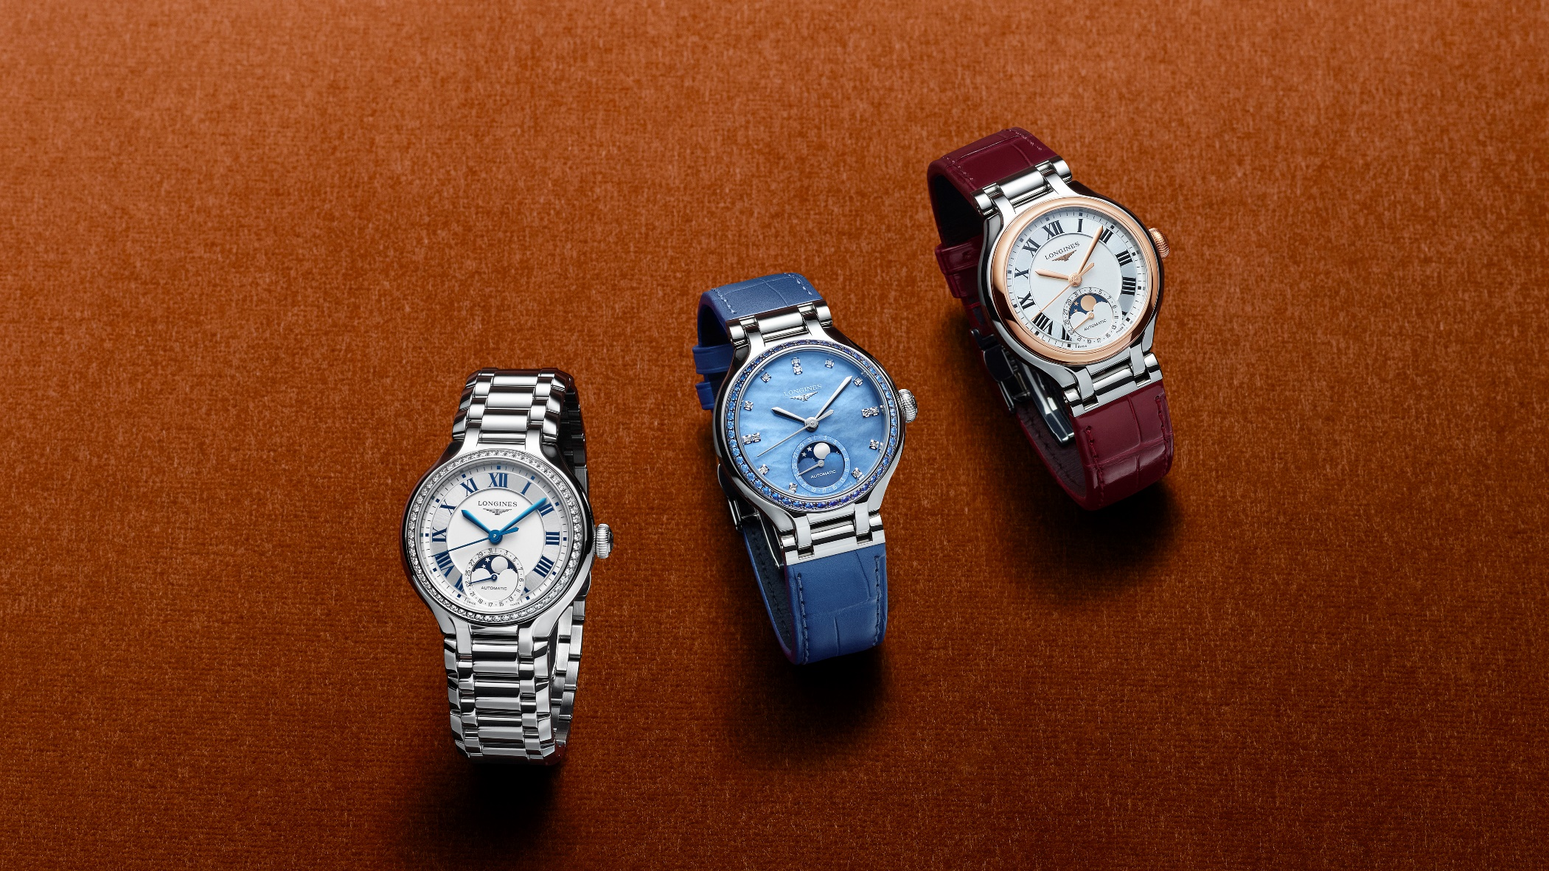

**The art of gem-setting and a focus on excellence**

**A masterpiece of exceptional elegance**

The extraordinary blue-dialled PrimaLuna represents the collection's pinnacle of horological artistry. It marks the first time in PrimaLuna history that the bezel is adorned with carefully selected sapphires. Forty-eight gemstones totalling 1.06 carats across four distinct hues and sizes create a subtle gradation that mirrors the infinite variations of the twilight sky. Paired with a unique celestial blue mother-of-pearl dial embellished with 14 diamond indexes, this timepiece transforms the traditional moonphase complication into a celestial celebration of colour, light, and Swiss horological mastery.

**Sublime sapphire**

For the first time, the exquisite use of sapphires – symbols of wisdom, royalty and timeless elegance – embellish the bezel in a subtle gradation of blue nuances and stone sizes. Renowned for their exceptional colour, hue, and brilliance, sapphires are among the hardest and rarest gemstones in the world. The gemstone is rated 9 on the Mohs scale of hardness, second only to diamond, ensuring exceptional scratch resistance. The sapphires chosen for this PrimaLuna are precisely cut and polished to achieve a flawless finish that will enhance both the aesthetic and tactile experience of the watch. Thanks to their vibrant colour, the sapphires imbue this jewellery watch with a distinctive character, with subtle variations ensuring that each piece is unique.

**Celestial harmony**

The dial is crafted from a new shade of blue – known as “celestial blue” – in mother-of-pearl and is embellished with 14 diamond indexes that complement the sapphire constellation above. A special pearly celestial blue leather strap that echoes the dial’s ethereal beauty completes this extraordinary timepiece, creating a harmonious expression of lunar elegance that extends from bezel to wrist. Every element works in perfect symphony to celebrate the infinite beauty of the night sky.

**JENNIFER LAWRENCE**

**Celebrating personal moments of elegance in the new PrimaLuna campaign**

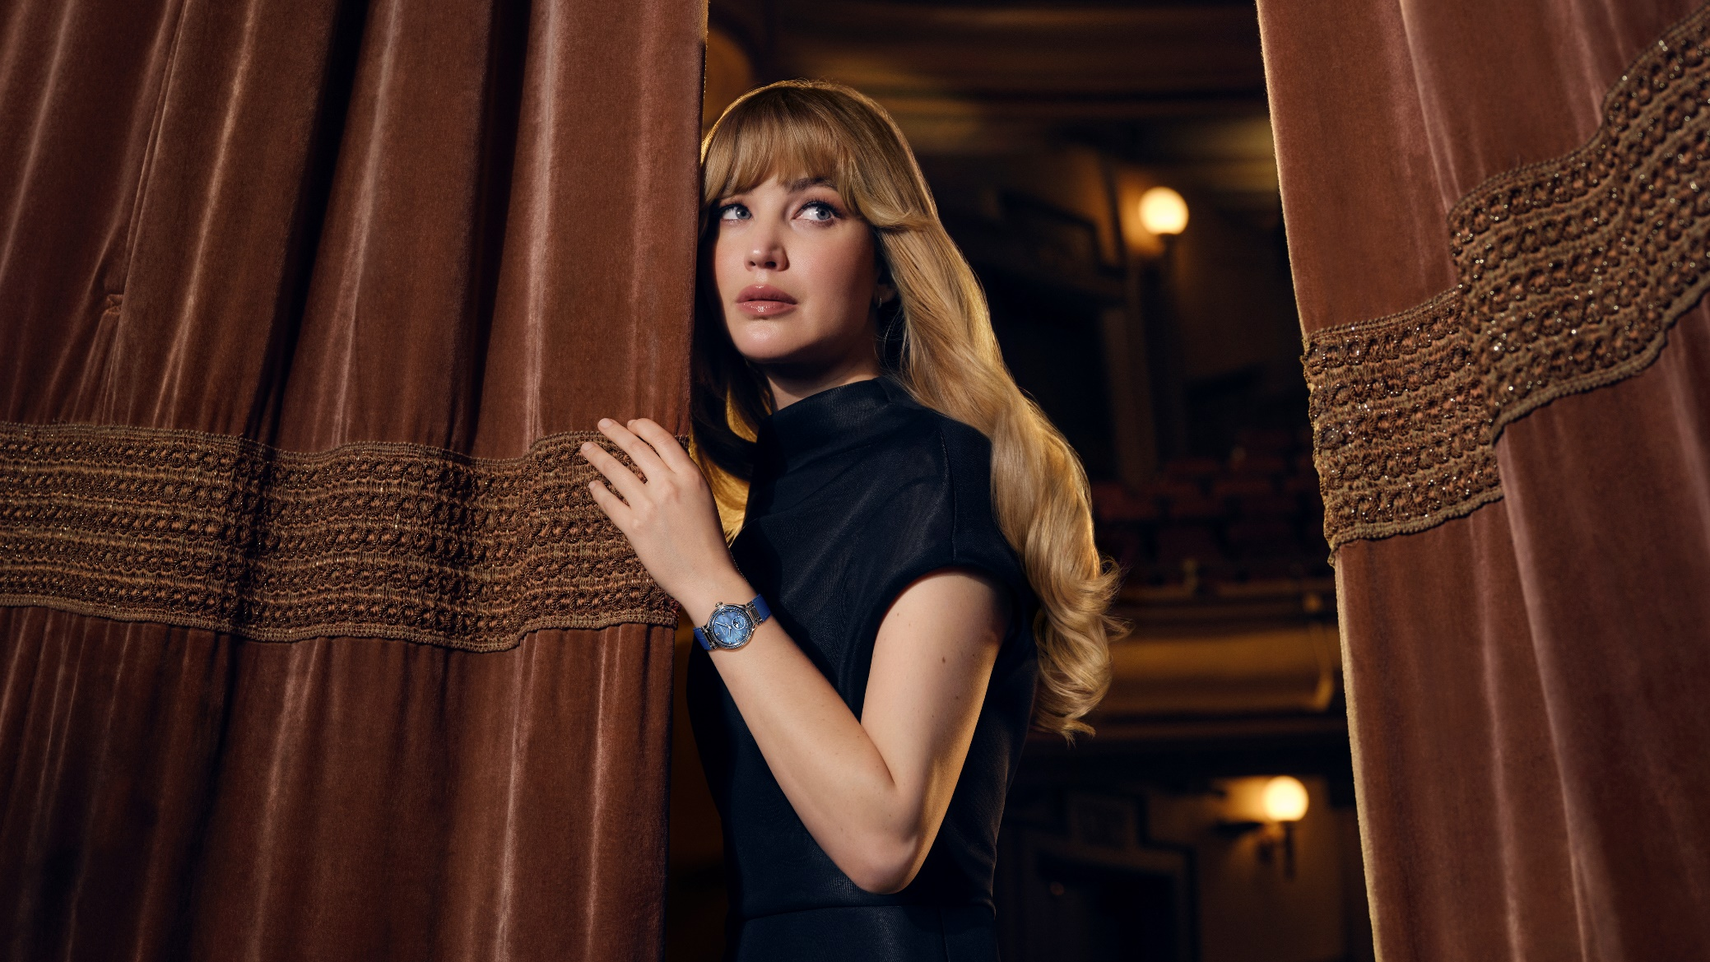

In the new PrimaLuna campaign, Longines Ambassador of Elegance Jennifer Lawrence embodies the intimate connection between timeless tradition and modern confidence. The campaign captures her in a solitary moment in an empty opera house, away from the crowds – a dreamlike, poetic atmosphere where she reconnects with spaces and experiences that hold personal meaning. This setting reflects how the PrimaLuna watch – with its blend of classic elegance and contemporary sophistication – is designed for life’s most private and meaningful moments. Through Jennifer’s natural grace and multifaceted character, the campaign demonstrates that true elegance isn’t about grand gestures but about finding beauty and significance in moments that are uniquely yours.

**Longines Ambassador of Elegance since 2022**

Jennifer Lawrence is an Academy Award–winning actress, producer and activist. She has starred in acclaimed films such as Silver Linings Playbook - which earned her the Academy Award for Best Actress in 2013 - American Hustle, Don’t Look Up, Joy, and The Hunger Games trilogy. In 2018, Lawrence expanded her influence behind the camera by co-founding Excellent Cadaver, a production company dedicated to telling bold, thought-provoking stories.

Together with her producing partner, Justine Ciarrocchi, Lawrence has cultivated a dynamic slate of critically lauded films, including No Hard Feelings, Causeway, and the powerful documentaries Zurawski v. Texas and Bread & Roses—the latter honoured with a prestigious Peabody Award. Their latest project, with Lawrence both starring in and serving as a producer, is a gripping adaptation of Die My Love, which premiered at the 2025 Cannes Film Festival and is slated for release in November. Beyond her work in film, she is a passionate advocate for gender equality and serves on the board of RepresentUs, a non-partisan organization working nationwide to pass powerful anti-corruption laws.

***“The new PrimaLuna watch feels timeless.  It has the kind of classic elegance that can easily go from day to night, casual to formal.”***

Jennifer Lawrence

***About our movements***

*Backed by centuries of watchmaking expertise, Longines has pioneered many technical advances and still displays an unfailing will to innovate. Its constant pursuit of excellence has led Longines to equip all its automatic timepieces with cutting-edge movements whose features include a silicon balance-spring. Silicon is not only lightweight and corrosion-resistant, but also impervious to normal temperature fluctuations and magnetic fields. Its unique properties boost the watch’s precision and longevity and allow Longines to guarantee these models for five years.*

#### About Longines

Longines has been established in Saint-Imier, Switzerland, since 1832. The watchmaking house boasts expertise forged in tradition, elegance, and high performance. With its long-standing experience as official timekeeper of world sports championships and partner of international sports federations, the Swiss watch brand has forged strong and lasting links with the sporting world over the years. Renowned for the elegance of its models, Longines is a member of Swatch Group Ltd, the world’s leading manufacturer of timepieces. The brand with the winged hourglass as its emblem has outlets in over 150 countries.